SIMATS ENGINEERING
ASSESSMENT TOOL 3

COURSE NAME: DESIGN AND ANALYSIS OF ALGORITHMS
COURSE CODE: CSA0601

COURSE OUTCOME COVERED

CO 4 : Solve optimization problems using dynamic programming and greedy strategies.
Levels of Rubrics
(BL-4, BL-5)

Assessment Tool Weightage: 10%

QUESTIONS: 10 Total Marks: 50

Annexure A

Comparative Analysis

Code of Conduct:

I U.Prabhavathi/192472067 (Name / Reg No) certify that this submission is my original work and that I have adhered to the guidelines specified for this assessment.

I understand that any violation of academic integrity rules will result in disciplinary action.

Signature of the student:U.Prabhavathi

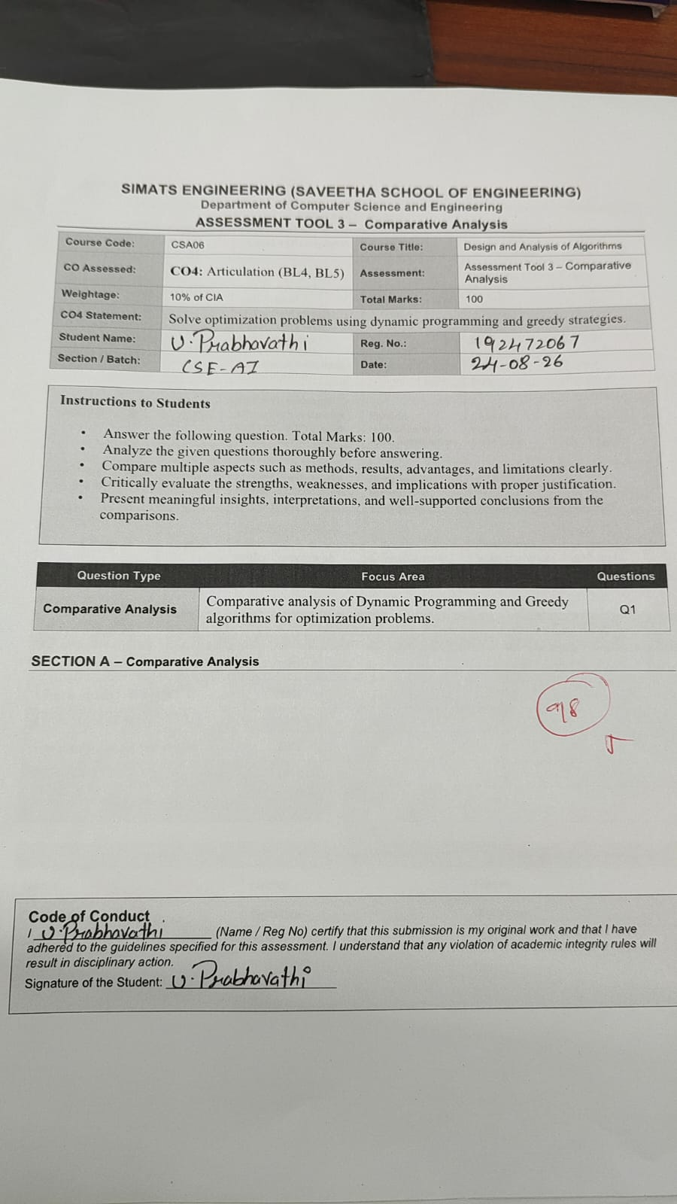
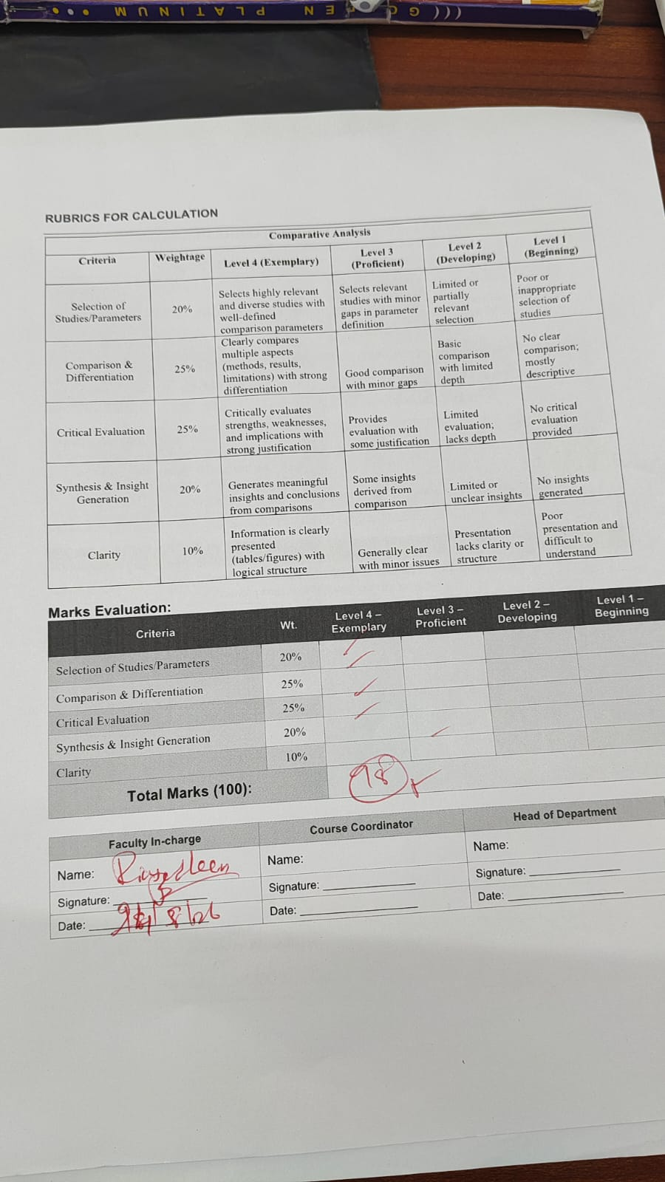
Annexure A

Comparative Analysis

Q96. Kruskal vs Prim (Edge vs Vertex Approach)
Compare Kruskal’s and Prim’s algorithms. Analyze differences in MST construction. Evaluate complexity. Discuss scalability. Examine implementation. Generate insights on MST techniques.
Q97. LPS vs Coin Change (String vs Numeric DP)
Compare Longest Palindromic Subsequence with Coin Change. Analyze differences in DP structure. Evaluate recurrence relations. Discuss complexity. Examine scalability. Generate insights on DP diversity.
Q98. Assembly Line vs Job Sequencing (DP vs Greedy Scheduling)
Compare Assembly Line Scheduling with Job Sequencing. Analyze differences in optimization strategies. Evaluate correctness. Discuss complexity. Examine scalability. Generate insights on scheduling algorithms.
Q99. TSP vs Floyd (Optimization vs Computation)
Compare Travelling Salesperson Problem with Floyd’s algorithm. Analyze differences in objective and complexity. Evaluate scalability. Discuss applicability. Examine limitations. Generate insights on algorithm selection.
Q100. DP vs Greedy Techniques (Comprehensive Comparative Analysis)
Compare Dynamic Programming and Greedy approaches across given problems. Analyze advantages and disadvantages. Evaluate complexity and scalability. Discuss correctness and optimality. Examine applicability. Generate insights on selecting suitable paradigms.

Comparative Analysis – Q96 to Q100

Q96. Kruskal vs Prim – Edge vs Vertex Approach
Main idea | Select minimum-weight edges | Select minimum-weight edge connecting a new vertex
Data structure | Disjoint Set / Union-Find | Priority Queue / Min Heap
Starting point | No specific starting vertex | Starts from any vertex
Cycle handling | Explicitly checks cycles | Naturally avoids cycles by adding new vertices
Best suited for | Sparse graphs | Dense graphs
Time Complexity | O(E log E) | O(E log V) with heap
MST Construction | Sorts all edges first | Grows one tree continuously
Scalability | Good for sparse graphs | Good for dense graphs
Main advantage | Simple edge selection | Efficient vertex expansion

Insight
Kruskal is preferable for sparse graphs, while Prim is often preferable for dense graphs. Both produce the Minimum Spanning Tree when the graph is connected and edge weights are suitable.

Q97. LPS vs Coin Change – String vs Numeric DP
Feature | Longest Palindromic Subsequence | Coin Change
Problem type | String problem | Numerical problem
Goal | Find longest palindromic subsequence | Find minimum coins / number of ways
DP structure | Usually 2D | Usually 1D or 2D
State | dp[i][j] for substring | dp[i] for amount
Recurrence | Depends on matching end characters | Depends on selecting a coin
Input | String | Coins and target amount
Time Complexity | O(n²) | O(n × amount)
Space Complexity | O(n²) | O(amount) in optimized version
Main challenge | Maintaining subsequence relationships | Handling different coin combinations
Application | Text processing | Currency/optimization problems

LPS Recurrence
If characters match:
dp[i][j] = dp[i+1][j-1] + 2
Otherwise:
dp[i][j] = max(dp[i+1][j], dp[i][j-1])

Coin Change Recurrence
dp[amount] = min(dp[amount], dp[amount-coin] + 1)

Insight
LPS demonstrates sequence-based 2D DP, while Coin Change demonstrates resource/amount-based DP. Both use overlapping subproblems but have very different state representations.

Q98. Assembly Line vs Job Sequencing – DP vs Greedy Scheduling
Feature | Assembly Line Scheduling | Job Sequencing
Technique | Dynamic Programming | Greedy
Objective | Minimize production time | Maximize profit
Decision | Stay on line or switch | Select profitable jobs
Input | Processing and transfer times | Deadlines and profits
State | Minimum time to reach station | Selected jobs/time slots
Strategy | Considers previous optimal states | Selects locally best job
Time Complexity | O(n) for two lines | Typically O(n log n) or O(n²)
Main Advantage | Considers multiple stages | Simple and fast
Main Challenge | State transitions | Finding feasible schedule
Application | Manufacturing | Job/task scheduling

Assembly Line Recurrence
T1[i] = min(T1[i-1] + a1[i], T2[i-1] + transfer + a1[i])
T2[i] = min(T2[i-1] + a2[i], T1[i-1] + transfer + a2[i])

Job Sequencing Strategy
- Sort jobs by decreasing profit.
- Select the most profitable available job.
- Place it in the latest available slot before its deadline.

Insight
Assembly Line Scheduling requires DP because previous decisions affect future decisions. Job Sequencing can use Greedy because selecting the highest-profit feasible job leads to an optimal solution under its standard assumptions.

Q99. TSP vs Floyd – Optimization vs Computation
Feature | TSP | Floyd-Warshall
Full Name | Travelling Salesperson Problem | Floyd-Warshall Algorithm
Objective | Find minimum-cost tour visiting every city | Find shortest paths between every pair
Technique | DP / Backtracking / Branch and Bound | Dynamic Programming
Output | One optimal tour | All-pairs shortest distances
Complexity | O(n²2ⁿ) using DP | O(n³)
Scalability | Poor for large n | Better for moderate-sized graphs
Graph type | Usually weighted complete graph | Directed/undirected weighted graph
Main challenge | Exponential search space | Cubic computation
Application | Route planning | Network routing
Limitation | Becomes very expensive as cities increase | Expensive for extremely large graphs

TSP DP Recurrence
dp[mask][i] represents the minimum cost of visiting the cities in mask and ending at city i.

Floyd-Warshall Recurrence
dist[i][j] = min(dist[i][j], dist[i][k] + dist[k][j])

Insight
TSP focuses on finding one optimal complete tour, whereas Floyd-Warshall calculates shortest paths between every pair of vertices. Floyd-Warshall is polynomial, while exact TSP solutions are generally exponential.

Q100. DP vs Greedy Techniques – Comprehensive Comparative Analysis
Feature | Dynamic Programming | Greedy
Decision method | Considers multiple possibilities | Makes best local choice
Main principle | Optimal substructure + overlapping subproblems | Greedy-choice property
Optimality | Usually guarantees optimal solution when correctly formulated | Only guarantees optimality for suitable problems
Memory | Usually requires more memory | Usually requires less memory
Complexity | Can be higher | Often lower
Speed | May be slower | Usually faster
Scalability | Can be difficult for very large state spaces | Generally highly scalable
Implementation | More complex | Usually simpler
Examples | LPS, Coin Change, Assembly Line, TSP | Job Sequencing, Activity Selection, Kruskal
Main advantage | Handles complex decision dependencies | Fast and memory efficient
Main disadvantage | Higher time/space requirements | May produce non-optimal solutions

Advantages of DP
- Guarantees optimal results for suitable problems.
- Handles overlapping subproblems efficiently.
- Useful when current decisions depend on previous decisions.

Disadvantages of DP
- Requires additional memory.
- Can have high time complexity.
- Designing the correct state and recurrence can be difficult.

Advantages of Greedy
- Simple to understand and implement.
- Usually faster than DP.
- Requires less memory.
- Works well for large inputs when the greedy property holds.

Disadvantages of Greedy
- Does not always produce an optimal solution.
- Requires proof of the greedy-choice property.
- A locally optimal decision may lead to a globally poor solution.

Algorithm Selection Insight
Use Dynamic Programming when:
- There are overlapping subproblems.
- The problem has optimal substructure.
- Previous decisions affect future decisions.
- An optimal solution requires comparing multiple possibilities.
Use Greedy when:
- A locally optimal choice can be proven to lead to a global optimum.
- Fast execution is important.
- The problem has a strong greedy-choice property.

Overall Conclusion
Kruskal vs Prim: Choose based on graph structure—Kruskal is edge-oriented and effective for sparse graphs, while Prim grows the MST from vertices.
LPS vs Coin Change: Both use DP but demonstrate different DP state structures—sequence-based versus numerical/resource-based.
Assembly Line vs Job Sequencing: Assembly Line uses DP to evaluate dependent decisions, while Job Sequencing uses Greedy to select profitable jobs.
TSP vs Floyd: TSP is an exponential optimization problem, while Floyd-Warshall efficiently computes all-pairs shortest paths in polynomial time.
DP vs Greedy: DP is more general for complex optimization problems, while Greedy is preferable when a provably correct local-choice strategy exists.

RUBRICS FOR CALCULATION

Comparative Analysis
Criteria | Weightage | Level 4 (Exemplary) | Level 3 (Proficient) | Level 2 (Developing) | Level 1 (Beginning)
Selection of Studies/Parameters | 20% | Selects highly relevant and diverse studies with well-defined comparison parameters | Selects relevant studies with minor gaps in parameter definition | Limited or partially relevant selection | Poor or inappropriate selection of studies
Comparison & Differentiation | 25% | Clearly compares multiple aspects (methods, results, limitations) with strong differentiation | Good comparison with minor gaps | Basic comparison with limited depth | No clear comparison; mostly descriptive
Critical Evaluation | 25% | Critically evaluates strengths, weaknesses, and implications with strong justification | Provides evaluation with some justification | Limited evaluation; lacks depth | No critical evaluation provided
Synthesis & Insight Generation | 20% | Generates meaningful insights and conclusions from comparisons | Some insights derived from comparison | Limited or unclear insights | No insights generated
Clarity | 10% | Information is clearly presented (tables/figures) with logical structure | Generally clear with minor issues | Presentation lacks clarity or structure | Poor presentation and difficult to understand

